LINUX SERVER MANAGEMENT – BASIC COMMANDS

Project Work

Submitted by:
Name: Ridhima Thakur

AIM:- To execute and understand basic Linux commands used for server management.

INTRODUCTION:-Linux is a powerful open-source operating system widely used for server management.
This project demonstrates the execution of basic Linux commands and explains their outputs.

- Command 1: pwd
Command: pwd
Output:
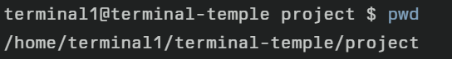
Explanation:
This command displays the present/absolute path of current working directory, i.e., the current location of the user in the Linux file system.
- Command 2: ls
Command: ls
Output:
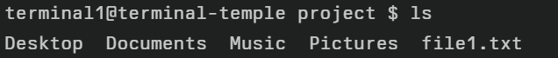
Explanation:
This command lists the files and directories present in the current directory.
This command verifies the creation of files by listing them in the directory.

- Command 3: ls -l
Command: ls -l
Output:
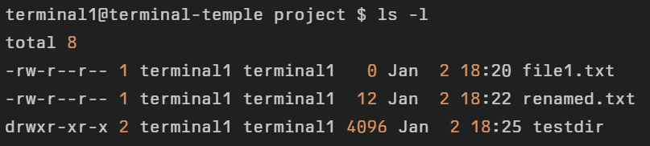
Explanation:
This command displays a detailed list of files and directories, including permissions, owner, file size, and last modified date.

- Command 4: mkdir
Command: mkdir testdir
ls
Output:
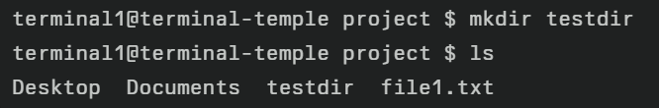
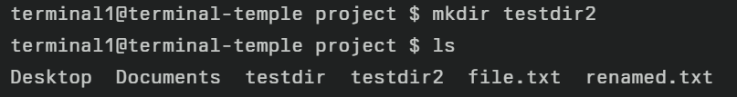
Explanation:
This command creates a new directory named testdir in the current location.

- Command 5: cd
Command: cd src
pwd
Output:
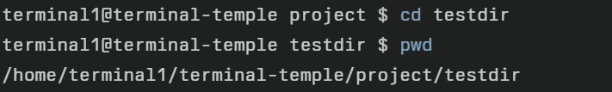
Explanation:
This command changes the current working directory to the src folder; followed by pwd that confirms the new path.

- Command 6: pwd (after cd)
Command: pwd
Output:
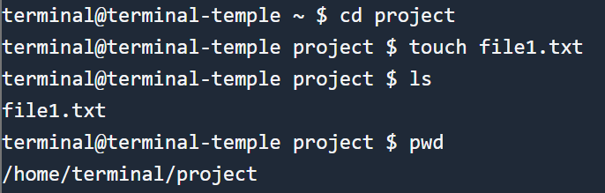
Explanation:
This command confirms the current directory after changing it.

- Command 7: touch
Command: touch file1.txt
ls
Output:
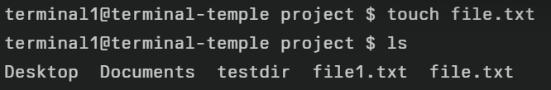
Explanation:
This command creates a new empty file named file1.txt if it does not exist, or updates its modification time if it does.

- Command 8: cp
Command: cp file1.txt file2.txt
ls
Output:
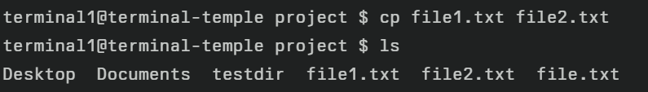
Explanation:
This command copies the contents of file1.txt into a new file named file2.txt in same directory.

- Command 9: mv
Command: mv file2.txt renamed.txt
ls
Output:
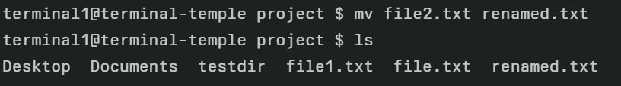
Explanation:
This command renames the file file2.txt to renamed.txt.(also used to move files or directories to a different path)

- Command 10: cat
Command: cat renamed.txt
Output:
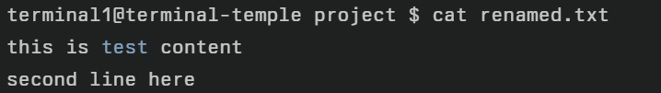
Explanation:
This command displays the contents of the file renamed.txt on the terminal.

- Command 11: chmod
Command: ls -l deploy.sh
chmod +x deploy.sh
ls -l deploy.sh
Output:
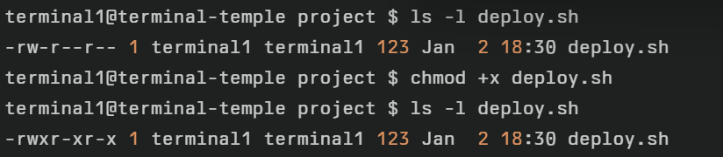
Explanation:
chmod +x deploy.sh adds only execute permission, turning deploy.sh into an executable script; the x bits appear in the permission string.

- grep
Command: grep "test" renamed.txt
Output:
Explanation:
Searches for a word in a file.

- sudo
Command: sudo apt update
Output:
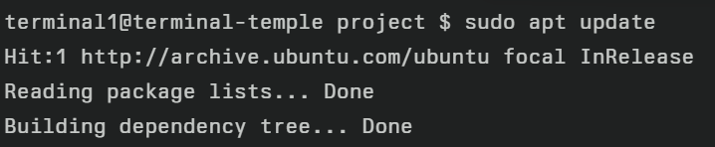
Explanation:
Note: This can fail in online terminals
Runs command with administrator privileges.

- Command 14: rmdir
Command: rmdir testdir2
Output:
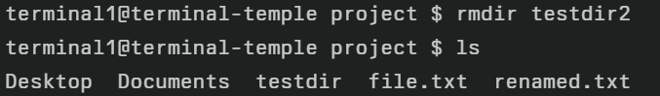
Explanation:
Deletes an empty directory.

- Command 15: rm
Command: rm file.txt
Output:
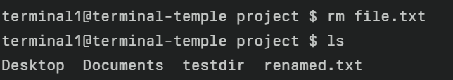
Explanation:
Removes the file permanently from file system.

- Command 16: clear
Command: clear
Output:
Explanation: clear the terminal screen,removes previous outputs.
Note: Shows empty screen after clear, then new prompt appears at top-left.

CONCLUSION:-
This project helped in understanding basic Linux commands used for server management.
These commands are essential for managing files, permissions, and system resources.

